GUIDELINES FOR AUTHORS PREPARING MANUSCRIPTS FOR PUBLICATION

Yildiz, F., ª* Tusat, E.,ª Karabork, H., ª Yakar, Mª., Karasaka, L., ª Yilmaz, H.M., ^{b}

ª Selcuk University, Engineering Faculty, Department of Geomatic Engineering, 42075 Konya, Turkey - (yildiz, tusat, karabork, yakar, karasaka@selcuk.edu.tr)
^{b} Aksaray University, Department of Geomatic Engineering, 68100 Aksaray,Turkey
hmyilmaz@aksaray.edu.tr

ABSTRACT:

These guidelines are provided for preparation of papers accepted for publication in EURASIAN GIS 2018. These guidelines are issued to ensure a uniform style throughout these two series. All papers that are accepted by the relevant scientific committee of an EURASIAN GIS 2018 event will be published provided they arrive by the due date and they correspond to these guidelines. Reproduction is made directly from author-prepared manuscripts, in electronic or hardcopy form, in A4 paper size 297mm x 210mm (11.69 x 8.27 inches). To assure timely and efficient production of the Archives and Annals with a consistent and easy to read format, authors must submit their manuscripts in strict conformance with these guidelines. The Society may omit any paper that does not conform to the specified requirements. There will be no opportunity for corrections or improvements of poorly prepared originals.

KEY WORDS: Manuscripts, Proceedings, Archives, Guidelines for Authors, Styleguide

MANUSCRIPT

General Instructions
The maximum paper length is restricted to 8 pages. Invited papers can be increased to 12 pages. The paper should have the following structure:

- Title of the paper
- Authors and affiliation
- Keywords (5-8 words)
- Abstract (100 – 250 words)
- Introduction
- Material and Methods
- Results and Discussion
- Conclusions
- Acknowledgements (if applicable)
- References
- Appendix (if applicable)

Page Layout, Spacing and Margins
The paper must be compiled in one column for the Title and Abstract and in two columns for all subsequent text. All text should be single-spaced, unless otherwise stated. Left and right justified typing is preferred.

Preparation in Electronic form
To assist authors in preparing their papers, styleguides for preparing digital versions of papers are provided in Word.

Length and Font
All manuscripts, except Invited Papers are limited to a size of no more than eight (8) single-spaced pages (A4 size), including abstracts, figures, tables and references.
The font type Times New Roman with a size of nine (9) points is to be used.

Setting | A4 size paper
 | mm | inches
Top | 25 | 1.0
Bottom | 25 | 1.0
Left | 20 | 0.8
Right | 20 | 0.8
Column Width | 82 | 3.2
Column Spacing | 6 | 0.25
Table 1. Margin settings for A4 size paper

TITLE AND ABSTRACT BLOCK

Title
The title should appear centered in bold capital letters, at the top of the first page of the paper with a size of twelve (12) points and single-spacing. After one blank line, type the author(s) name(s), affiliation and mailing address (including e-mail) in upper and lower case letters, centred under the title. In the case of multi-authorship, group them by firm or organization as shown in the title of these Guidelines.

Key Words
Immediately after the abstract, in bold capital letter, provide a maximum of 5-8 keywords, using American spelling and avoiding general and plural terms and multiple concepts (avoid, for example, 'and', 'of'). Be sparing with abbreviations: only abbreviations firmly established in the field may be eligible. These keywords will be used for indexing purposes.

Abstract
Leave two blank lines under the key words. Type "ABSTRACT:" flush left in bold Capitals followed by one blank line. Start now with a concise Abstract (100 - 250 words) which presents briefly the content and very importantly, the news and results of the paper in words understandable also to non-specialists.

MAIN BODY OF TEXT
Type text single-spaced, with one blank line between paragraphs and following headings. Start paragraphs flush with left margin.

Headings
Major headings are to be centered, in bold capitals without underlining, after two blank lines and followed by a one blank line.

Type subheadings flush with the left margin in bold upper case and lower case letters. Subheadings are on a separate line between two single blank lines.

Subsubheadings are to be typed in bold upper case and lower case letters after one blank line flush with the left margin of the page, with text following on the same line. Subsubheadings may be followed by a period or colon, they may also be the first word of the paragraph's sentence.

Us decimal numbering for headings and subheadings

Footnotes
Mark footnotes in the text with a number (1); use the same number for a second footnote of the paper and so on. Place footnotes at the bottom of the page, separated from the text above it by a horizontal line.

Illustrations and Tables

Placement: Figures must be placed in the appropriate location in the document, as close as practicable to the reference of the figure in the text. While figures and tables are usually aligned horizontally on the page, large figures and tables some-

times need to be turned on their sides. If you must turn a figure or table sideways, please be sure that the top is always on the left-hand side of the page.

Captions: All captions should be typed in upper and lower case letters, centered directly beneath the illustration. Use single spacing if they use more than one line. All captions are to be numbered consecutively, e.g. Figure 1, Table 2, Figure 3.

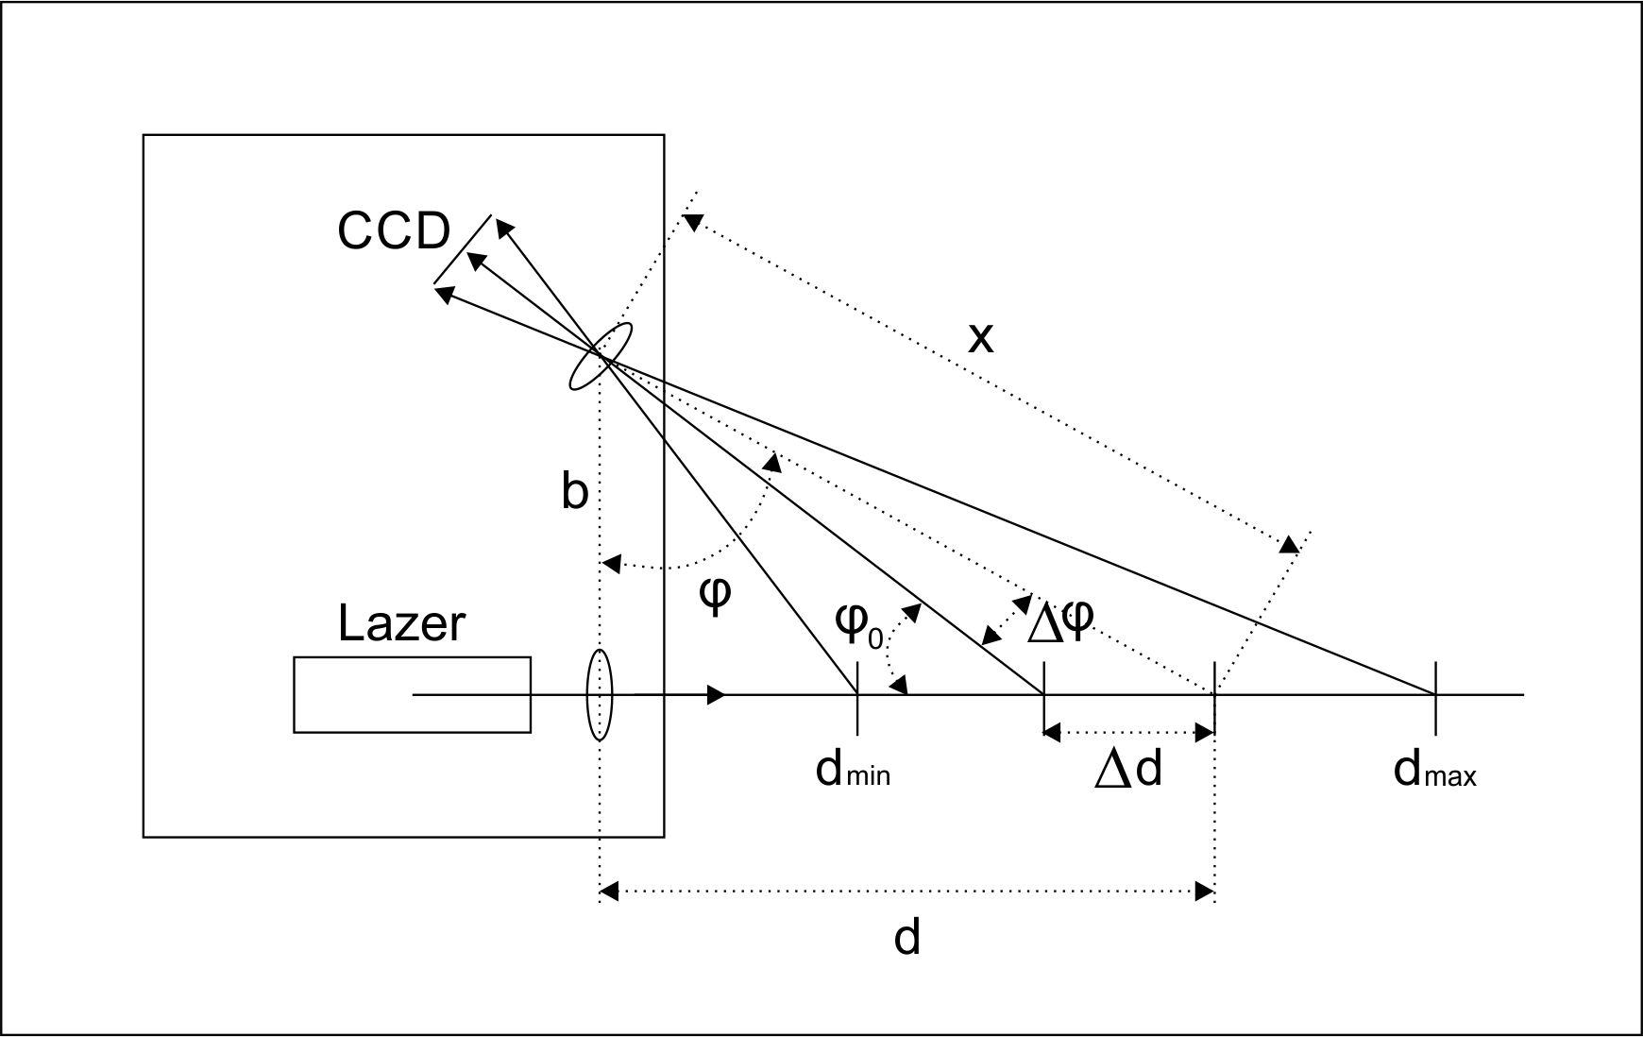
Figure 1. Figure placement and numbering

Copyright: If your article contains any copyrighted illustrations or imagery, please include a statement of copyright such as: © SPOT Image Copyright 20xx (fill in year), CNES. It is the author's responsibility to obtain any necessary copyright permission. After publication, your article is distributed under the Creative Commons Attribution 3.0 Unported License and you retain the copyright.

Equations, Symbols and Units

Equations: Equations should be numbered consecutively throughout the paper. The equation number is enclosed in parentheses and placed flush right. Leave one blank lines before and after equations:

$m_{b}=\frac{h_{g}}{f}$ (1)

where $m_{b}$= photo scale
f = focal length
$h_{g}$ = the height of the projection centre above ground

Symbols and Units: Use the SI (Système Internationale) Units and Symbols. Unusual characters or symbols should be explained in a list of nomenclature.

References
References should be cited in the text, thus (Smith, 1987b), and listed in alphabetical order in the reference section. The following arrangements should be used:

References from Journals: Journals should be cited like (Smith, 1987a). Names of journals can be abbreviated according to the "International List of Periodical Title Word Abbreviations". In case of doubt, write names in full.

References from Books: Books should be cited like (Large et al., 2009).

References from Other Literature: Other literature should be cited like (Legat, 2006) and (Pfeifer et al., 2007).

References from websites: References from the internet should be cited like (Johansson, 2002).

Acknowledgements (optional)
Acknowledgements of support for the project/paper/author are welcome.

References
Johansson, M. (2002): Explorations into the behavior of three different high-resolution ground-based laser scanners in the built environment. Proc. of the CIPA WG6 Int. Workshop on scanning for cultural heritage recording. http://www.isprs.org/commission5/workshop/
Legat, K., 2006. Approximate direct georeferencing in national
coordinates. ISPRS Journal of Photogrammetry and Remote
Sensing 60 (4), 239–255.

Pfeifer, N and Briese, C., 2007, Laser scanning-principles and applications, Geo-Sibir, Nowosibirsk, III International Scientific Conference, pp. 93 - 112

Smith, J., 1987a. Close range photogrammetry for analyzing distressed trees. Photogrammetria, 42(1), pp. 47-56.
Smith, J., 1987b. Economic printing of color orthophotos. Report KRL-01234, Kennedy Research Laboratories, Arlington, VA, USA.
Large, R.G. Andrew and Heritage, L. George, 2009, Laser scanning-Evolution of the dicipline, Laser Scanning for the Environmental Sciences, pp.1-20, 278 pg., ISBN:978-1-405-15717-9, Wiley-Blackwell, Oxford

Appendix (optional)
Any additional supporting data may be appended, provided the paper does not exceed the limits given above.

* Corresponding author. This is useful to know for communication with the appropriate person in cases with more than one author.

